

**SQL DOCUMENT**

**ON**

**MOVIE RENTAL DATA ANAYSIS**

DONE

BY

BHARATHWAJ

**Description:**

Movie On Rent is a chain of movie rental stores operating in a certain country. It has a collection of movies in DVD and Blue disc formats. The management of the company wants to analyze what kind of movies are most often rented, which Genre they belong to, and which actors appeared in them. It will help the management stock up the inventory as per audience’s preferences for improved business.

**Sakila Database Schema Diagram:**

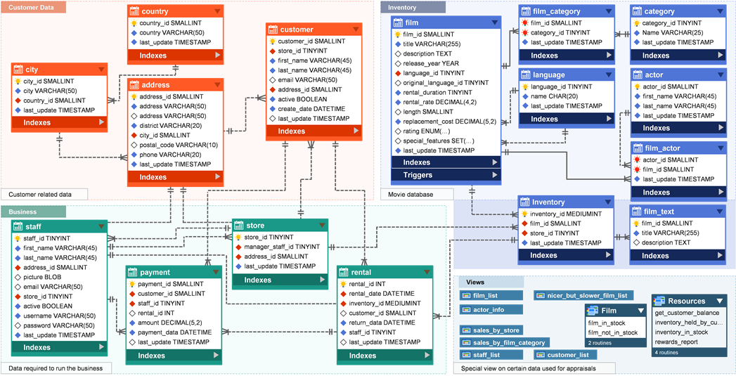

* **Task 1:** For displaying the full names of actors I have used concat function to get combine two columns in order to get the full name of actors.
* **Task 2 & 3:** To find the names that appearing frequently in the database I have used count function so that we can get exact count of repeating numbers.
* To display the unique first names in database I have used distinct function.
* **Task 4:** To display the list of records with particular movie rating I have used where condition to filter rating ‘R’.
* To display the records of movies except the mentioned rating I have used where condition with not equals to so that we can get remaining movie ratings.
* **Task5:** For displaying the list of records for movies replacement cost up to $11, I have used where condition for filtering records.
* To display records of movies replacement cost in between two values I have used where condition with the between operator to get range of values in between $11 and $20.
* To display records in the descending order used order by condition.
* **Task 6:** To display top 3 movies with highest number of actors I have used joins for joining of two tables grouped by title and for top3 I have used order by and limit.
* **Task 7:** For displaying the movie titles starting ‘K’ and ‘Q’ used like operator with or condition.
* **Task 8:** To display the actor names first used concat function to combine two columns and used joins to get the movie wise actor names and at last used where condition with selected movie title.
* **Task 9:** To get the particular category names I have used joins with two tables and used where condition to get particular category films.
* **Task 10:** For displaying maximum, minimum, average rental rates of the film I have used max(), min(), avg() functions and used group by with ratings, order by for getting values in descending order.
* **Task 11:** To get the difference of average replacement cost and average film rental rate first we need to find average of replacement cost and rental rate after that I have joins to join multiple tables and used group by for grouping of category names and used having clause to filter values less than 15.
* **Task 12:** For displaying category wise film taken count of film titles and joined with multiple tables used group by for grouping with category names used having clause to give condition of less than 70.